Try this!
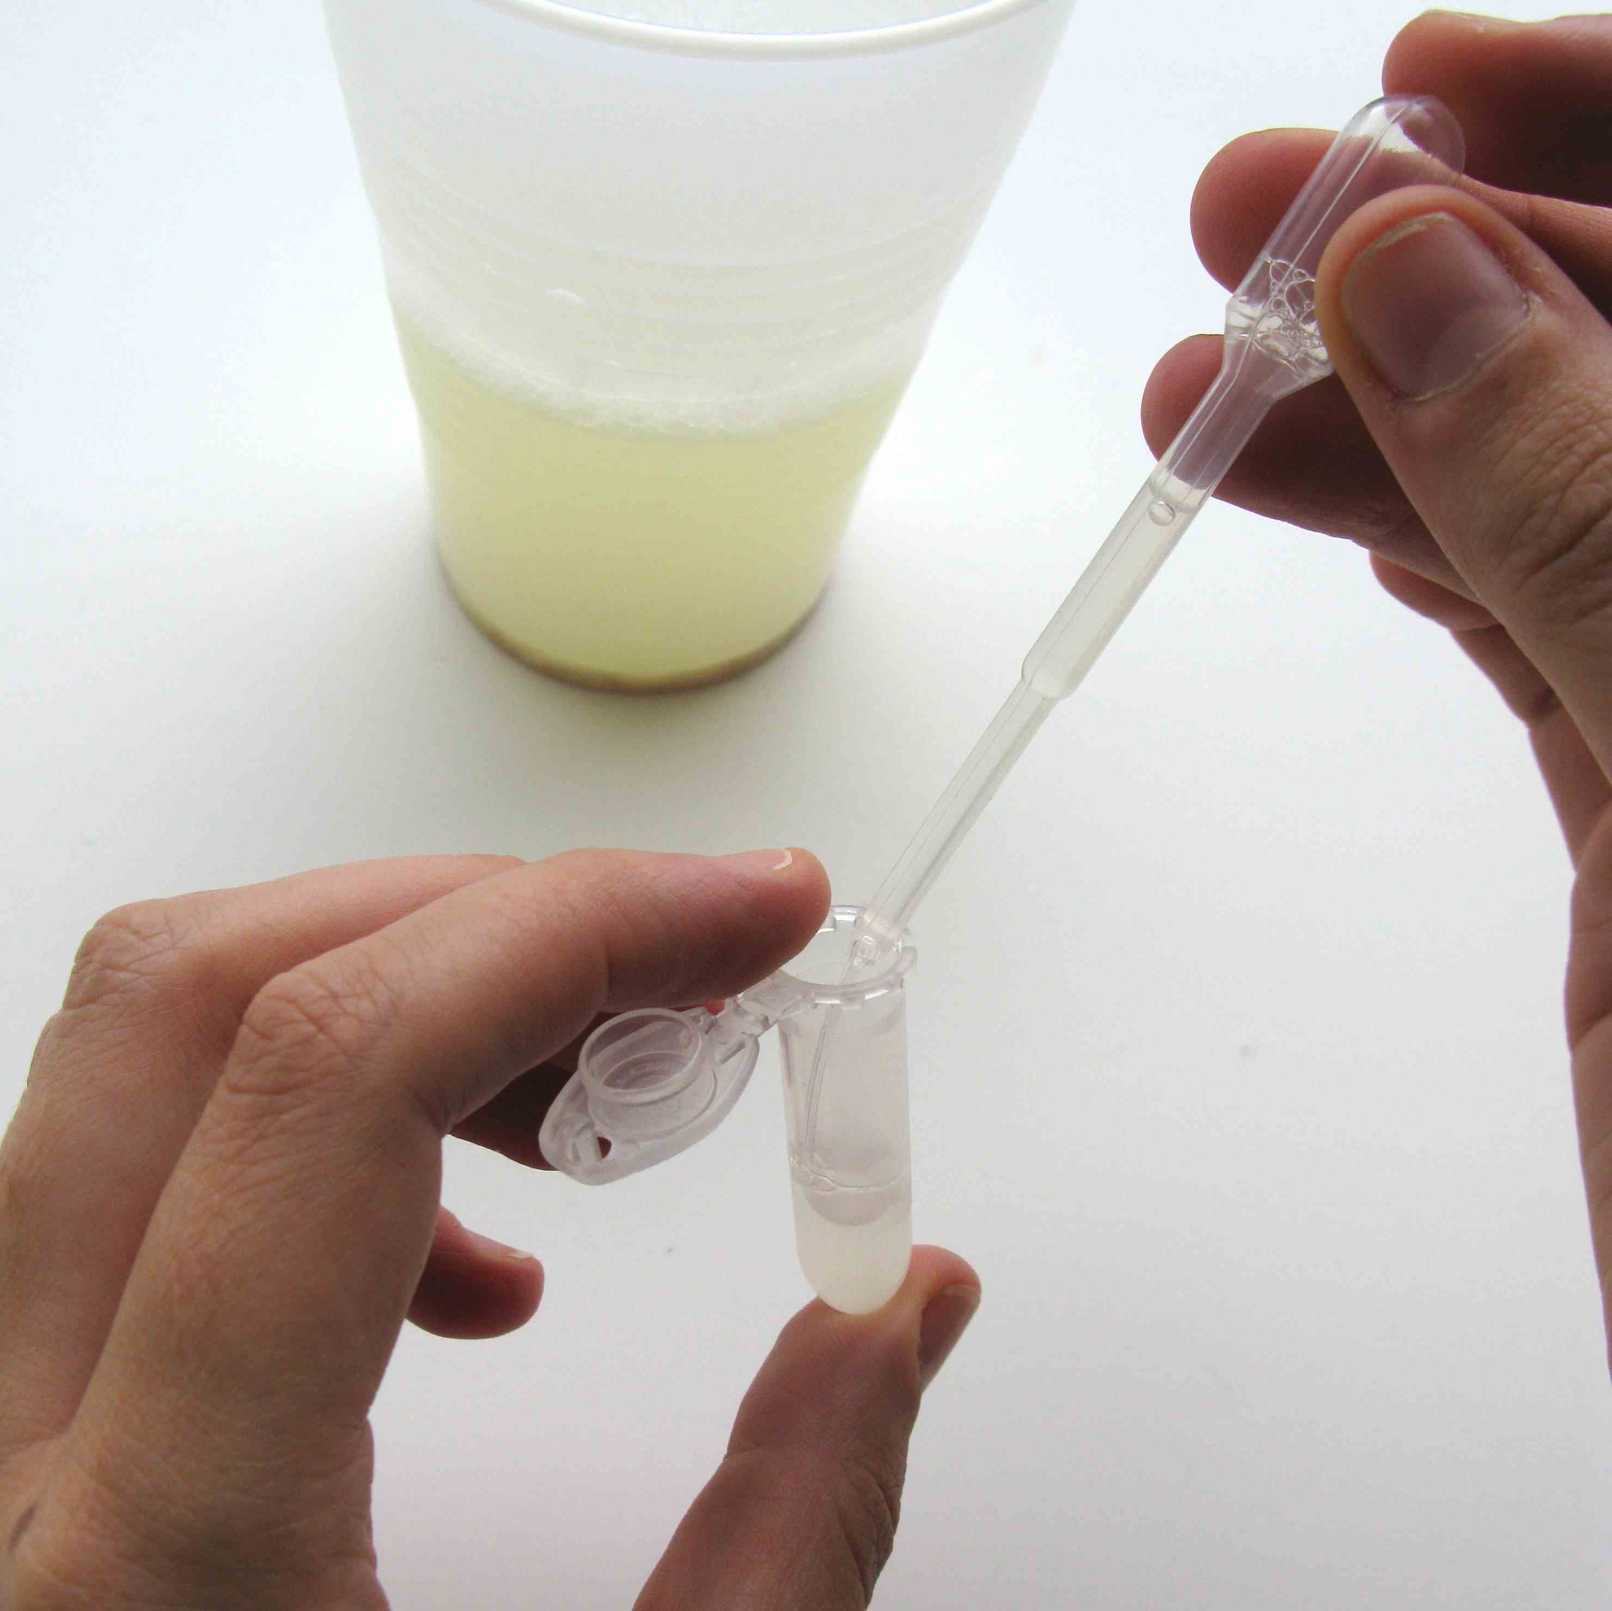
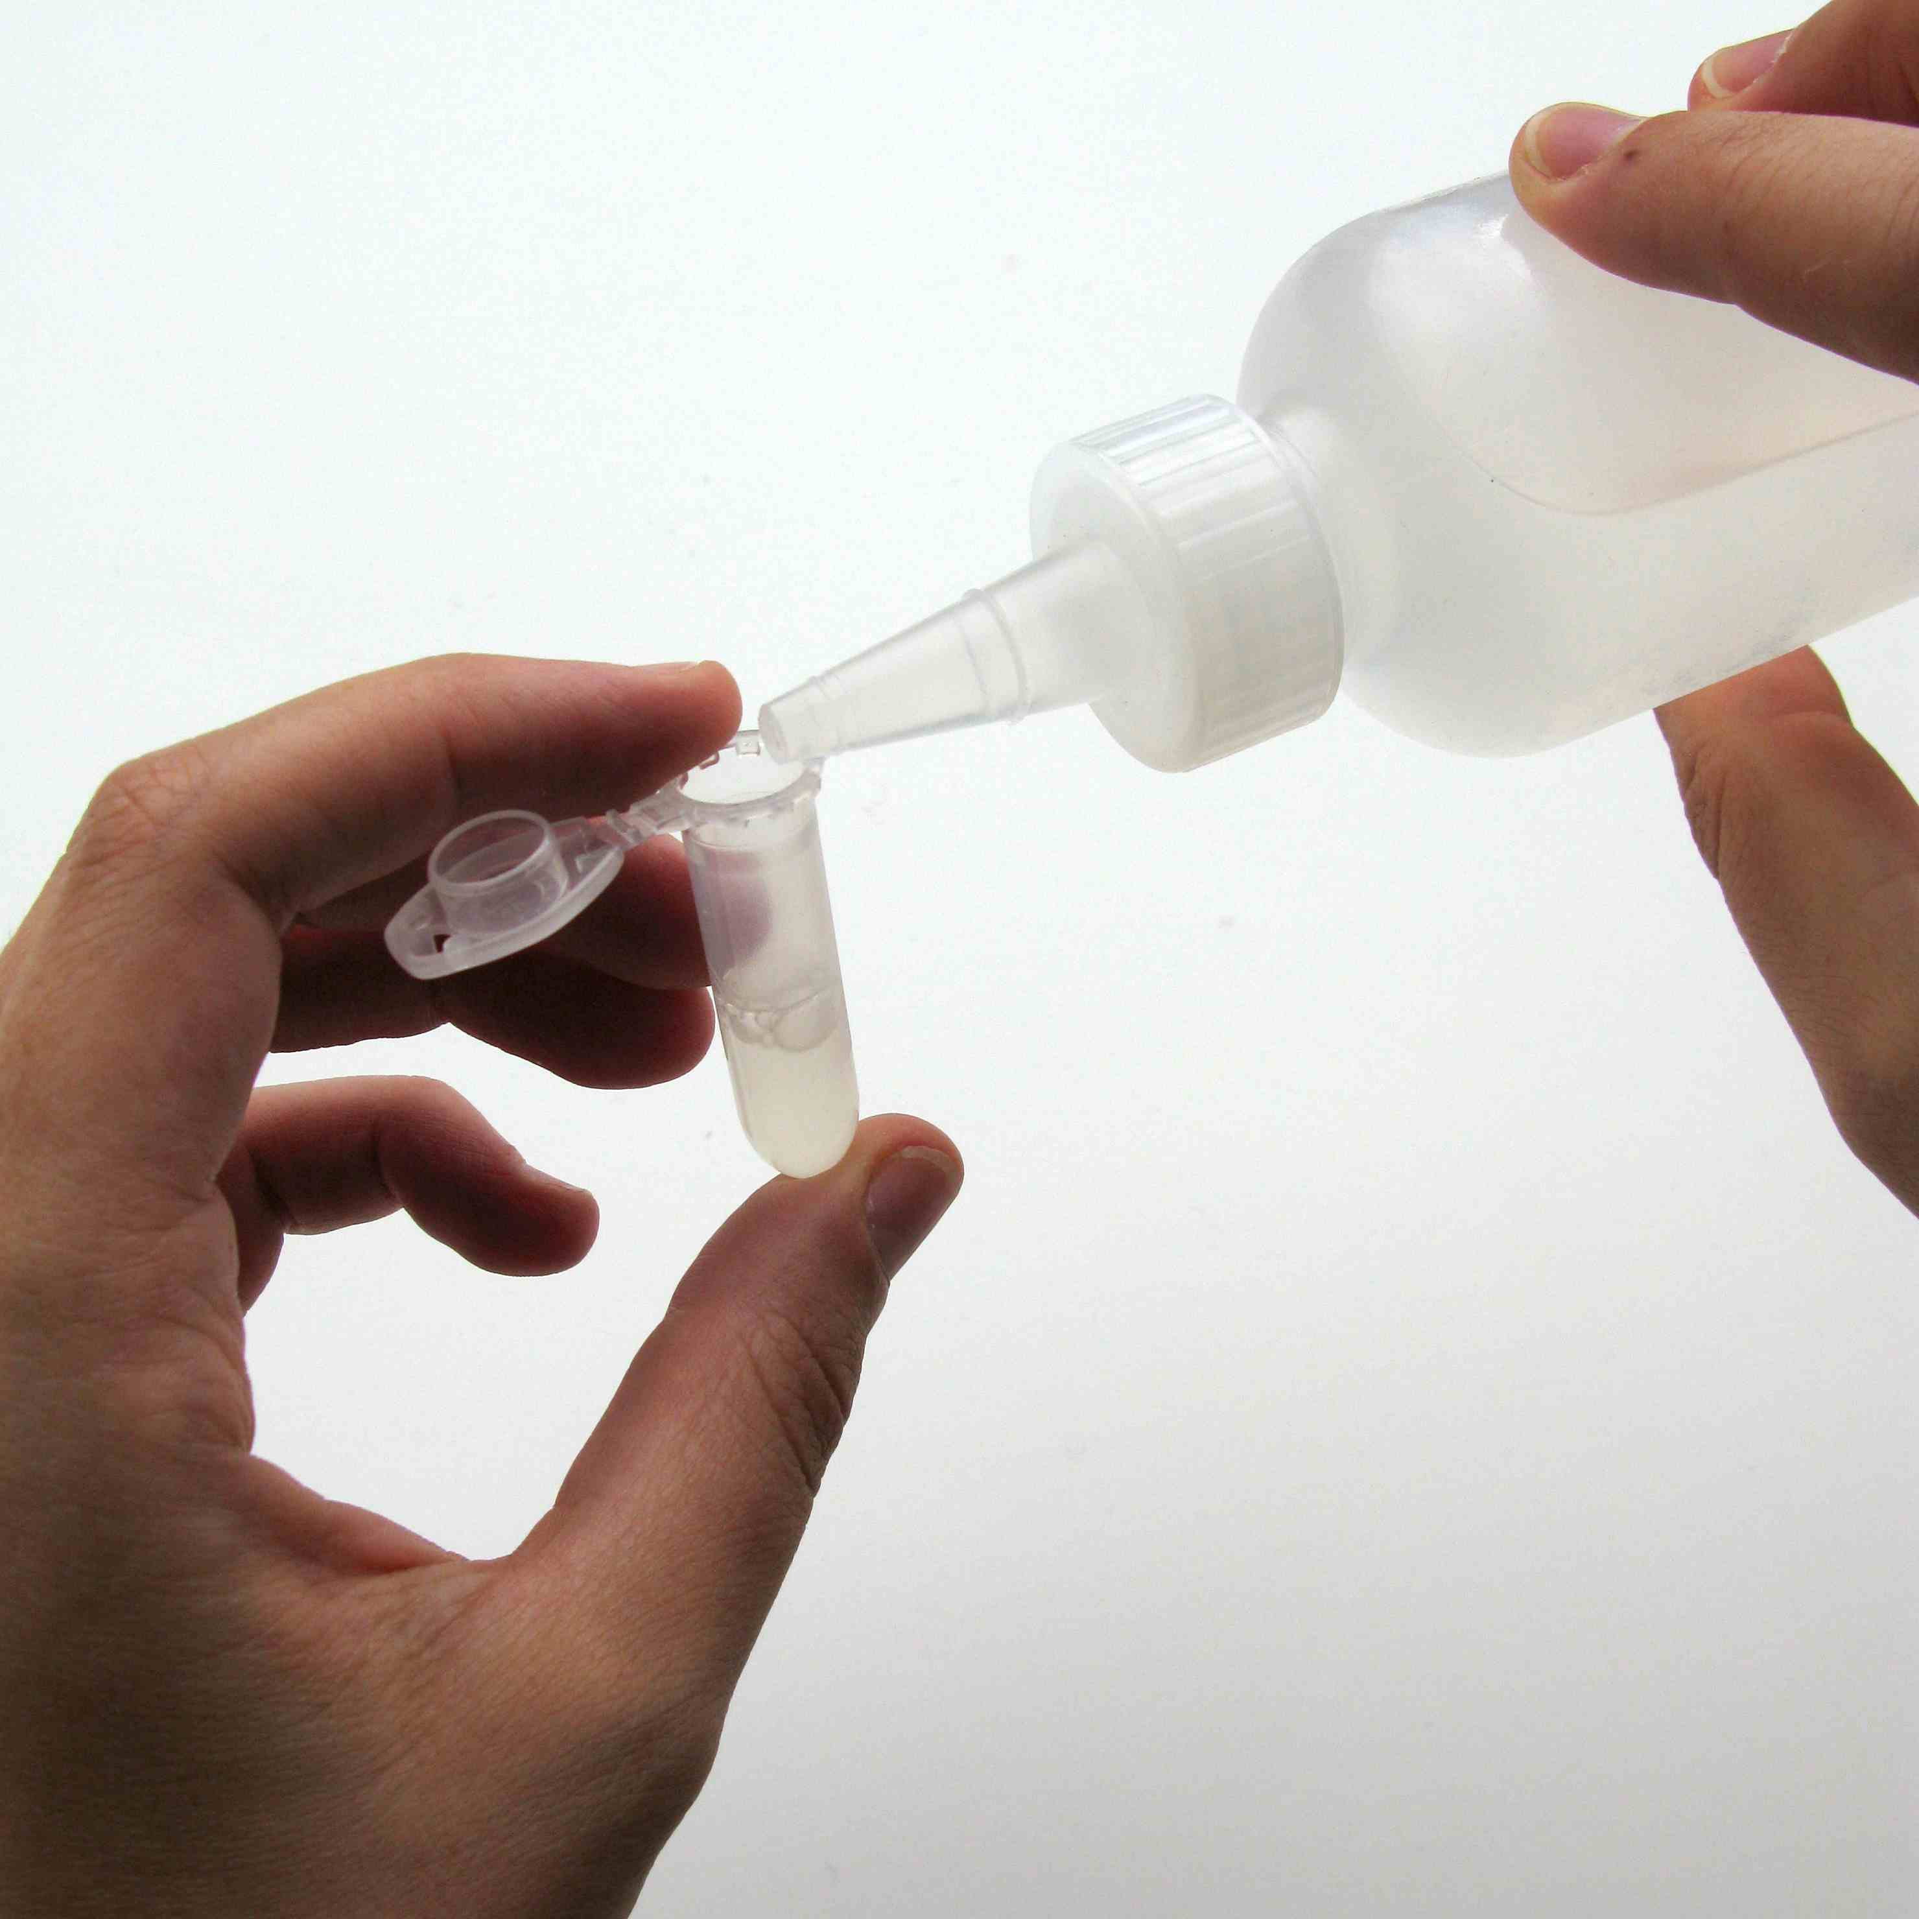
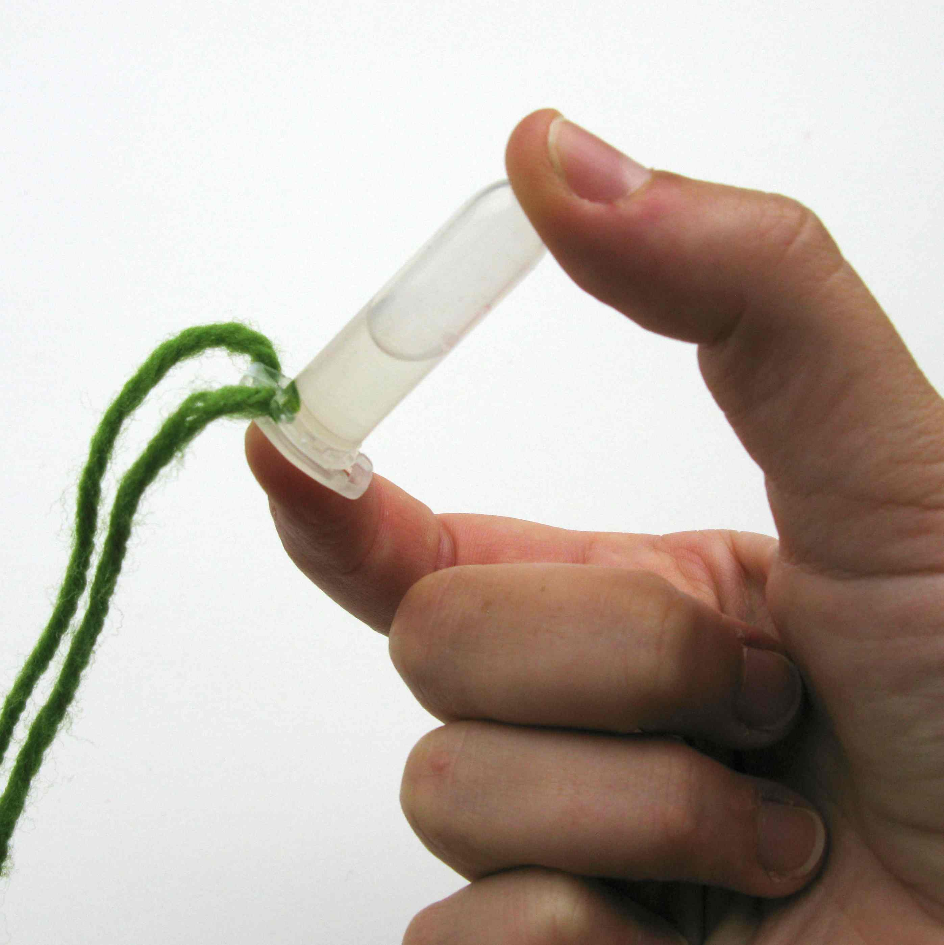
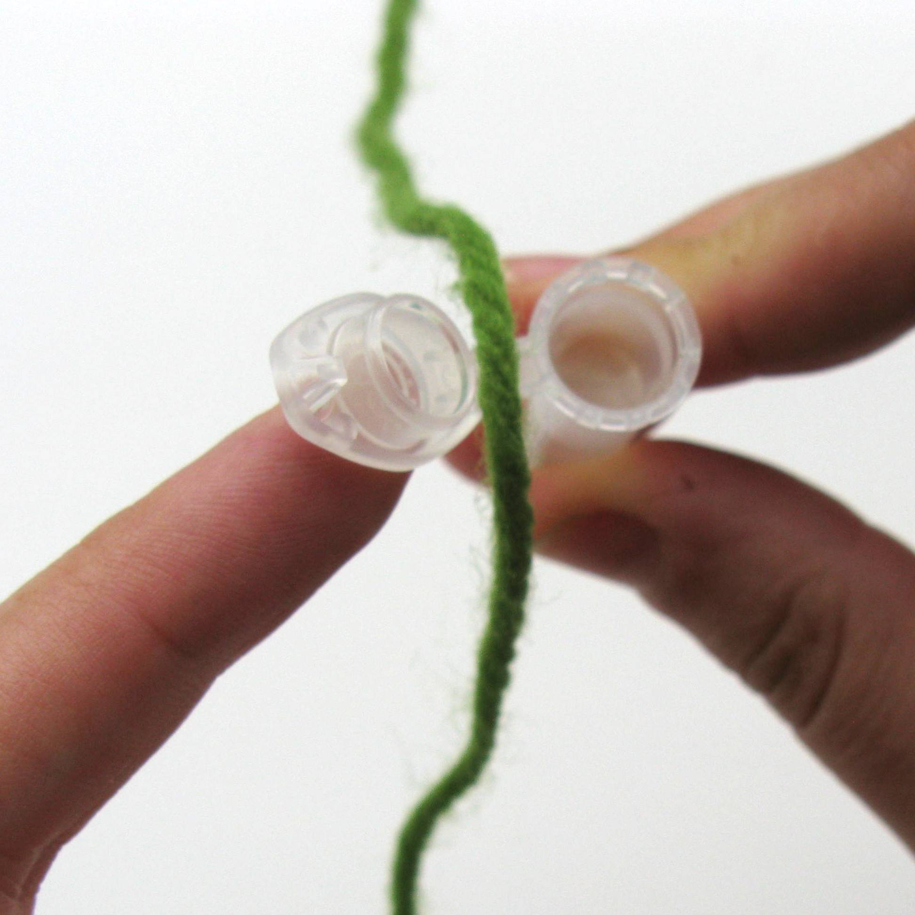
1. Use a pipette to fill a plastic tube halfway with wheat germ liquid.
1
2
3
4

2. Use the dropper bottle to add alcohol to the tube. Fill it almost all the way to the top.

3. Snap the lid shut and gently rock the tube a few times. Look inside. Can you see anything forming in the tube?
Those clumps are made of wheat DNA! Every living thing contains DNA, which stands for deoxyribonucleic acid. DNA gives cells the instructions they need to grow and do their jobs.
4. Open the lid, and put a piece of yarn over the edge of the cap. Snap it shut again and tie the yarn. Now you have a DNA necklace!

Talk about it…
This DNA comes from wheat germ. What kind of instructions do you think the DNA from a wheat plant contains? Would any of these instructions be useful in a different organism?
Can you think of a change we could make to a wheat plant’s DNA to make it more useful to us?

Synthetic biology develops tools and knowledge to build new living organisms and materials.

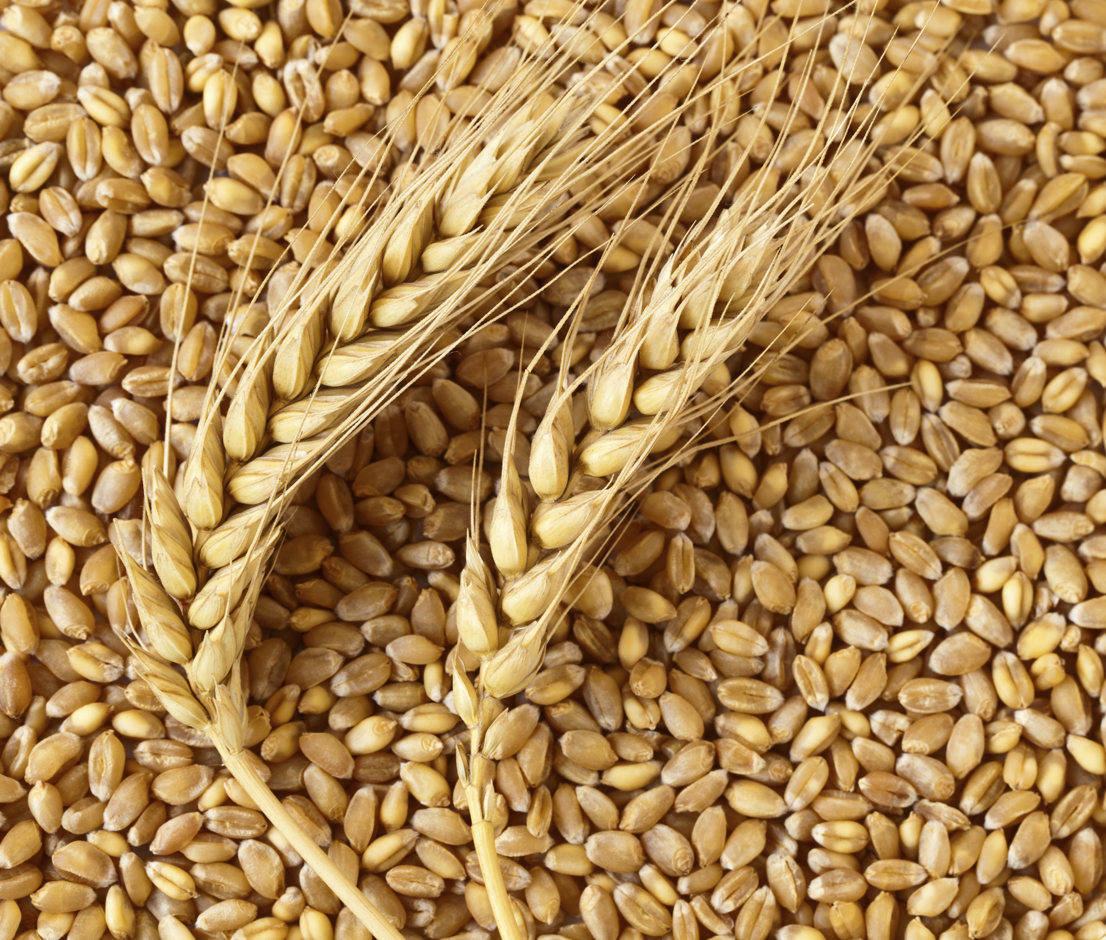
The ability to modify and build using DNA is essential to synthetic biology. All plant and animal cells contain deoxyribonucleic acid, or DNA, the building block of life. DNA helps cells grow and do different jobs.
Researchers are already very good at identifying and isolating specific sections, or sequences, of DNA that correspond to different funtions. Synthetic (human-made) DNA can even be printed using a special printer!
Using tools from genetics and biology, scientists and engineers can mix and match pieces of DNA to “program” living systems in a way that is kind of like computer programming. This allows researchers to modify or build new living organisms and materials.
Wheat germ is the part of the seed that contains the plant’s genetic material. Farmers have selectively bred wheat over thousands of years to produce larger, more nutritious kernels.

Synthetic biology benefits from many voices. People participate from many different fields, including art, science, engineering, public policy, and political science.
Synthetic biologists design, build, and test new organisms. This work can take place in universities, companies, and community DIY (do-it-yourself) labs.
Even if you’re new to the ideas in synthetic biology, your opinions can shape the development of its tools and applications. What existing problems do you think synthetic biology could solve? What new issues might emerge as we develop new technologies using living materials?
Synthetic biology lets people engineer living things. For example, yeast can be modified to produce the fragrance of a rose.

